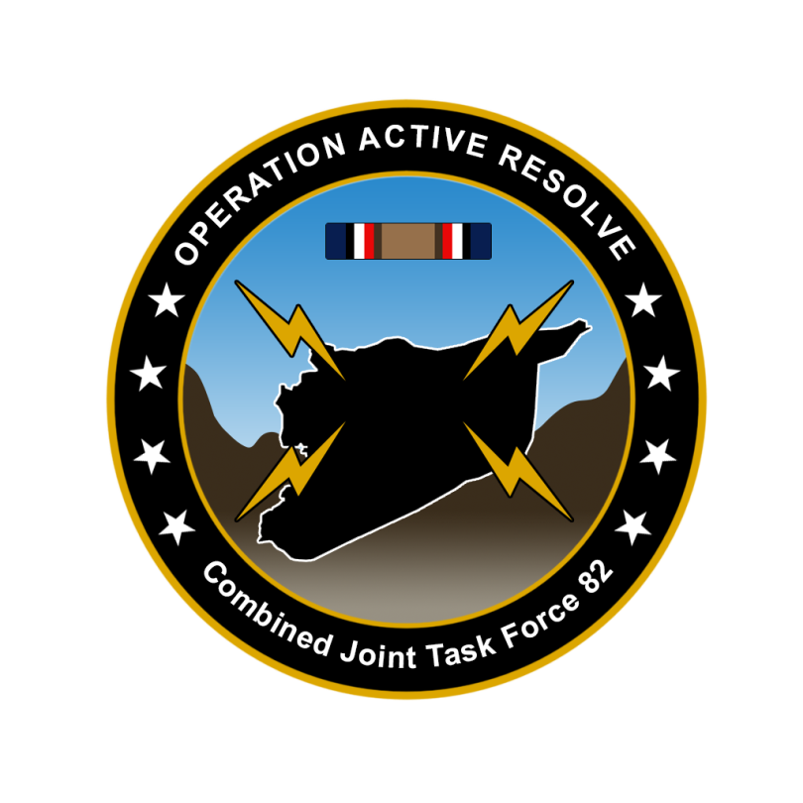

CJTF-82 DIRECTION AND GUIDANCE

D+4

This document covers the friendly situation from D+3 and provides CJTF-82 guidance to the entire force.

**Reference CombatFlite**: <https://132nd-vwing.github.io/OPAR-Brief/MISSION%20INFORMATION/Friendly_update.cf>

# SITUATION

## General situation

September 1st 2011 JFACC initiated airstrikes against Syrian forces while LCC started preparing its offensive. On D+3 LCC with its IV Corps in Sector North started its offensive.

There has been a higher Russian activity in the eastern Mediterranean than normal and this I likely due the presence and operations from CJTF-82.

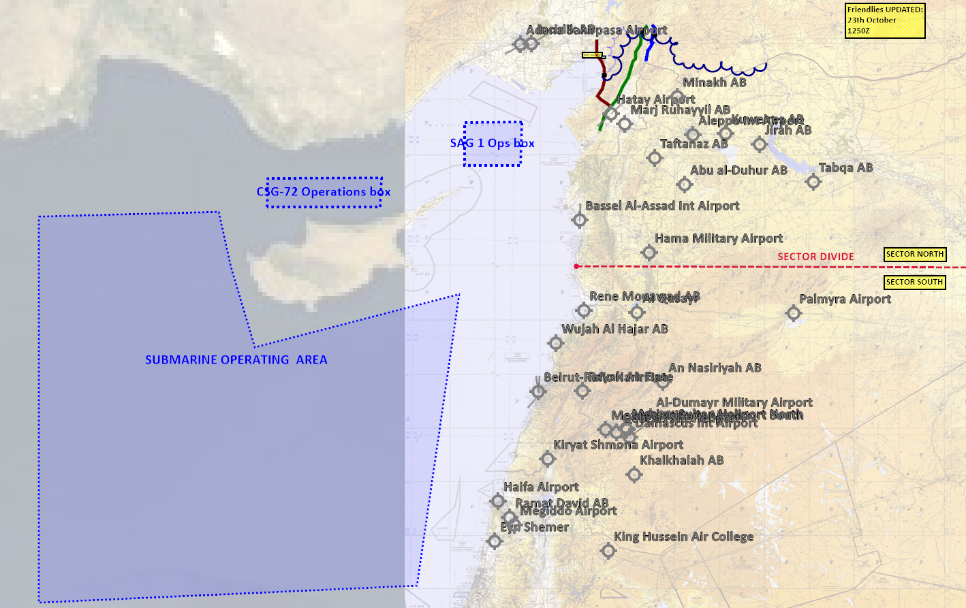

## Friendly situation

### Land Component Command (LCC)

#### IV Corps (Northern sector)

IV Corps in the NORTH have started their offensive. IV Corps are using three roads as their main line of advance to the SOUTH. Along MSR RED there have only been light resistance and currently the 41st Division have halted its advance while waiting for the 42nd Division moving SOUTH along MSR GREEN and MSR BLUE. There are multiple roads connecting MSR GREEN WEST toward the coast and IV Corps fear that Syrian forces may move forces toward the WEST to attack 41st Division in its rear area. 41st Division will not resume its offensive until 42nd Division have reached the same E-W line so they can attack simultaneous and keeping the rear safe.

42nd Division have met heavy resistance of multiple Company sized Main Battle Tank formations that have not been destroyed by JFACCs AR missions in the previous days and this have slowed down the progress significantly. Forces from 42nd Division will now hold its current positions until 1200Z D+4 before resuming its push towards the SOUTH.

#### III Corps (southern sector)

III Corps was planned to starts its offensive today (D+4). However, due to low attrition of the Syrian 3rd Corps the offensive is delayed. III Corps will start its offensive when conditions are set for starting the offensive. Conditions set for offensive start is 35% attrition on the following enemy units:

* 30th Armored Division (Syrian 3rd Corps)
* 31st Mechaniced Division (Syrian 3rd Corps)
* 32nd Motorized Division (Syrian 3rd Corps)

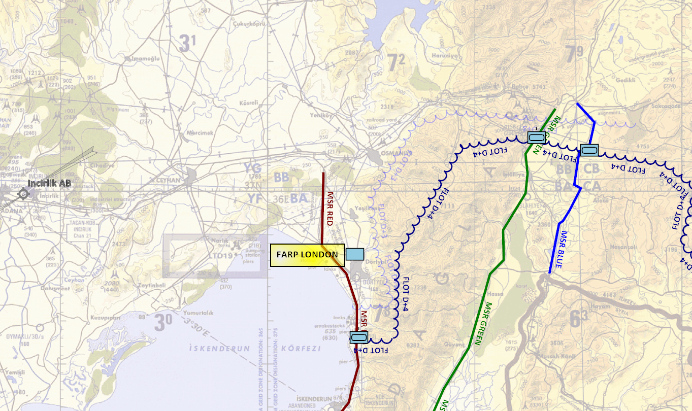

### Maritime Component Command (MCC)

* CSG-72 continue to support the mission from CSG-72 operations box.
* SAG-1 continue to support the mission by providing air defence coverage in the Incirlik region from SAG-1 operations box.
* CJTF MCC have been given command of a attack submarine, SSN-688 USS Los Angeles. The mission for the submarine is to deny Russia freedom of action in the eastern Mediterranean

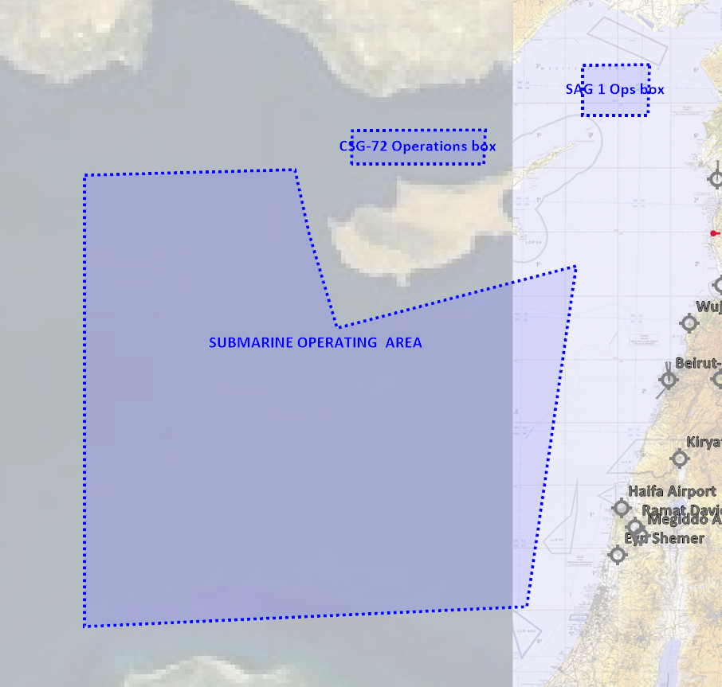

### Joint Force Air Component Command (JFACC)

* IAW JFACC JAOP and AOD’s

### Special Operations Component Command (SOCC)

* Several SOF teams have started insertion into Syria to prepare for CJTF-82 Operations order phase 2.
* SOF teams are also on standby to conduct counter terrorism missions and counter insurgency operations

# Reported Battle Damage Assessment

## IV Corps (Northern Sector)

* 45xT-72 destroyed (plus support vehicles)
* 27x BTR-80 destroyed (plus support vehicles)
* 4x SA-19
* 3x SA-9
* 7x ZSU-23/4

## III Corps (Southern Sector)

* 9x BTR-80
* 9x BMP-2

# Direction and Guidance

## LCC:

* Priority of effort is on the NORTHERN sector and support of IV Corps in defeating Syrian 1st Corps and restoring the Turkish border and create a buffer to Incirlik airbase.
* Once Turkeys border have been restored, shift focus to SOUTHERN sector and support III Corps in defeating the Syrian 3rd Corps and restoring the Israeli border and create buffer to Ramat David Airbase

## MCC:

* Be prepared to move SAG-1 SOUTHWEST in the eastern Mediterranean in order to create a robust threshold for any incursion of non-friendly naval forces.

## JFACC:

* Priority of effort is on establishing Air Superiority
* For support to LCC, follow Directions and Guidance to LCC, section 3.1.

## Diplomatic situation

* Syria is declared as enemy
* Russia is declared as adversary
* Jordan is declared as neutral
* Lebanon is declared as neutral
* Turkey is declared as friendly
* Israel is declared as friendly

Only units declared as enemy can and should be engaged by CJTF forces.

**Definitions:**

Adversary: opponent in a contest, conflict, or dispute toward CJTF and friendly forces.

Enemy: is actively opposed or hostile to CJTF and friendly forces.

Neutral: not supporting or helping either side in a conflict, disagreement, etc.; impartial.